Ideation Phase Empathize&Discover

|  |  |
| --- | --- |
| Date | 26June2025 |
| TeamID | LTVIP2025TMID3376 |
| ProjectName | Pattern sense:ClassifyingFabricPatternsusingDeep Learning |
| MaximumMarks | 4Marks |

**EmpathyMapCanvas:**

An empathy map is a simple, easy-to-digest visual that captures knowledge about a user’sbehaviours and attitudes.

**Think&Feel**

* Whyisthispatternnotdetectedcorrectly?
* I'munsureif themodelis accurate.
* Ihopethefabricisclassifiedwellforproduction.
* Worriedaboutmisclassification.

**See**

* Fabricsamplesorimages uploaded.
* ConfusingUI orunclear outputs.
* Limitedpatterncategoriesshown.
* Classificationlabelswithoutconfidence scores.

**Hear**

* “Thisdesignisnotproperlytagged.”
* “Itdoesn'tdetecttraditionalpatternswell.”
* “Weneedautomationforfabricsorting.”

**Say&Do**

* Triesmultipleimageuploadstocheckaccuracy.
* Questionsthemodel'soutput.
* Givesfeedbackonconfusingclassifications.
* Asksformorepatterntypestobeadded.

**Pain**

* Misclassifiedorunrecognizedpatterns.
* Limiteddatasetaffectingaccuracy.
* Unclearfeedbackoruserinterface.

**Gain**

* Quickandaccuratefabricclassification.
* Betterproductionplanning.
* 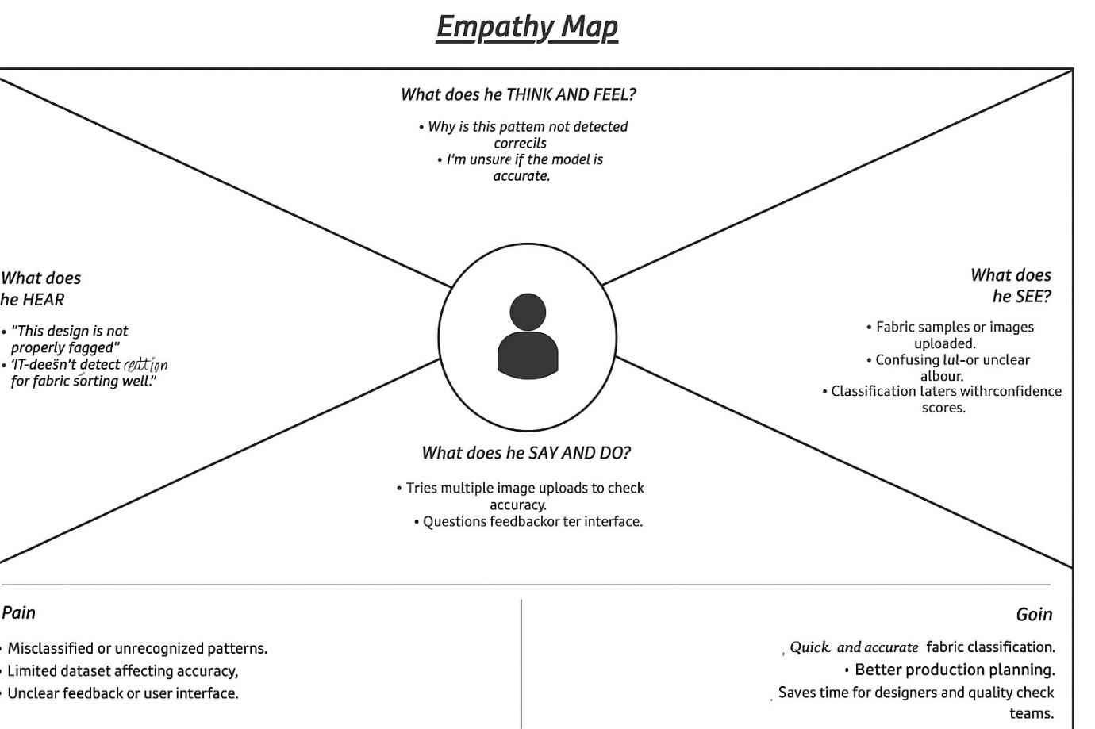Savestimefordesignersandqualitycheck teams.

**Example:TextileQualityChecker/Designer/ProductionSupervisor**

